“**Introduction to Environmental Engineering**”

Course Syllabus

Course Code：09045003

Course Category：Major Core

Majors：Engineering Class (Grade II)

Opening Semester：Fall

Credit：2 units

Instructor：Sheng-Peng Sun

Textbook：Mackenzie L. Davis and David A. Cornwell, Introduction to Environmental Engineering (Fourth Edition), 2007.

**Teaching Aim**

This course is intended to provide students an overview of the fundamental aspects of environmental engineering. Introduction to environmental engineering with a focus on using the concept of materials and energy balance as a tool to understanding environmental processes and solving environmental engineering problems. Topics covered include the physics of water behavior above and below ground, water resources and treatment, air quality and pollution, protection of ozone layer, global warming, noise pollution, resource conservation and recovery of solid waste, hazardous waste management, and reduction of the volume of radioactive waste. It provides the fundamental science and engineering principles in relevant chapters, which help the student analyze and understand the environmental engineering issues. Also, regulations will be discussed.

**Chapter I**

**Introduction**

***What is Environmental Engineering?***

Engineering

Environmental Engineering

***Environmental Systems Overview***

Systems as Such

Water Resource Management System

Air Resource Management System

Solid Waste Management

Multimedia Systems

Sustainability

***Environmental Legislation and Regulation***

Acts, Law, and Regulations

Water Quality Management

Air Quality Management

Noise Pollution Control

Solid Waste

Hazardous Wastes

Atomic Energy and Radiation

***Environmental Ethics***

Case: To Add or Not to Add

**Chapter II**

**Materials and Energy Balances**

***Unifying Theories***

Conservation of Matter

Conservation of Energy

Conservation of Matter and Energy

***Materials Balances***

Fundamentals

Time as a Factor

More Complex Systems

Efficiency

The State of Mixing

Including Reactions

Reactors

Reactors Analysis

***Energy Balances***

First Law of Thermodynamics

Fundamentals

Second Law of Thermodynamics

**Chapter III**

**Hydrology**

***Fundamentals***

The Hydrologic Cycle

Surface Water Hydrology

Ground Water Hydrology

Hydrologic Mass Balance

***Rainfall Analysis***

Point Precipitation Analysis

***Runoff Analysis***

Estimation of Amount of Runoff

Estimation of Time of Arrival

Estimation of Probability of Occurrence

***Groundwater and Wells***

Aquifers

Well hydraulics

Groundwater Contamination

**Chapter IV**

**Water Treatment**

***Introduction***

Water Quality

Physical Characteristics

Chemical Characteristics

Microbiological Characteristics

Radiological Characteristics

Water Quality Standards

***Coagulation***

Colloid Stability

Colloid Destabilization

Coagulation

***Mixing and Flocculation***

Rapid Mix

Flocculation

***Softening***

Hardness

Lime-Soda Softening

Ion-Exchange Softening

***Sedimentation***

Overview

***Filtration***

Overview

***Disinfection***

Overview

**Chapter V**

**Wastewater Treatment**

***Introduction***

Wastewater Treatment Perspective

***Characteristics of Domestic Wastewater***

Physical Characteristics

Chemical Characteristics

Characteristics of Industrial Wastewater

***Wastewater Treatment Standards***

Overview

***Municipal Wastewater Treatment Systems***

Overview

**Chapter VI**

**Air Pollution**

***Introduction***

Air Pollution Perspective

***Air Pollution Standards***

Overview

***Effects of Air Pollutions***

Effects on Materials

Effects on Vegetation

Effects on Health

***Origin and Fate of Air pollutants***

Carbon Monoxide

Hazardous Air Pollutants

Lead

Nitrogen Dioxide

Photochemical Oxidants

Particulates

Sulfur Oxides

***Micro and Macro Air Pollution***

Indoor Air Pollution

Acid Rain

Ozone Depletion

Global Warming

***Air Pollution Meteorology***

The Atmospheric Engine

Turbulence

Stability

Terrain Effects

***Atmospheric Dispersion***

Factors Affecting Dispersion of Air Pollutants

Dispersion Modeling

***Air Pollution Control***

Overview

**Chapter VII**

**Solid Waste Engineering**

***Introduction***

Magnitude of the Problem

***Characteristics of Solid Waste***

Overview

***Solid Waste Management System***

Overview

***Solid Waste Collection***

Overview

***Solid Waste As Resource***

Recycling

Composting

Energy Recover

***Solid Waste Reduction***

Overview

***Solid Waste Disposal***

Sanitary Landfill

**Chapter VIII**

**Hazardous Waste Management**

***Introduction***

Dioxins and PCBs

***EPA’s Hazardous Waste Designation System***

Overview

***RCRA and HSWA***

Congressional Actions on Hazardous Waste

Cradle-t-Grave Concept

Generator Requirements

Transporter Requirements

Treatment, Storage, and Disposal Requirements

Underground Storage Tanks

***CERCLA and SARA***

Overview

***Hazardous Waste Management***

Waste Minimization

Waste Exchange

Recycling

***Hazardous Waste Treatment***

Overview

***Hazardous Waste Land Disposal***

Overview

***Groundwater Contamination and Remediation***

Overview

**Chapter IX**

**Noise Pollution**

***Introduction***

Properties of Sound Waves

Sound Power and Intensity

Levels and the Decibel

Characterization of Noise

***Effects of Noise on People***

Overview

***Rating System***

Goals of a Nosie-Rating System

The *L*n Concept

The *L*eq Concept

The *L*dn Concept

***Community Noise Sources and Criteria***

Transportation Noise

Other Internal Combustion Engines

Construction Noise

Zoning and Siting Considerations

Levels to Protect Health and Welfare

***Transmission of Sound Outdoors***

Inverse Square Law

Radiation Fields of a Sound Source

Directivity

Airborne Transmission

***Traffic Noise Prediction***

Overview

***Noise Control***

Overview

**Chapter X**

**Ionizing Radiation**

***Fundamentals***

Atomic Structure

Radioactivity and Radiation

Radioactive Decay

Radioisotopes

Fission

The Production of X-Rays

Radiation Dose

***Biological Effects of Ionizing Radiation***

Sequential Pattern of Biological Effects

Determinants of Biological Effects

Acute Effects

Relation of Dose to Type of Acute

Radiation Syndrome

Delayed Effects

Genetic Effects

***Radiation Standards***

Overview

***Radiation Exposure***

External and Internal Radiation Hazards

Naturel Background

X-Rays

Radionuclides

Nuclear Reactor Operations

Radioactive Wastes

***Radiation Protection***

Reduction of External Radiation Hazards

Reduction of Internal Radiation Hazards

***Radioactive Waste***

Overview

**Class Hours for Each Chapter**

|  |  |  |
| --- | --- | --- |
| Chapter | Contents | Class hours |
| 1 | Introduction | 4 |
| 2 | Materials and Energy Balances | 4 |
| 3 | Hydrology | 4 |
| 4 | Water Treatment | 4 |
| 5 | Wastewater Treatment | 4 |
| 6 | Air Pollution | 6 |
| 7 | Solid Waste Engineering | 4 |
| 8 | Hazardous Waste Management | 2 |
| 9 | Noise Pollution | 2 |
| 10 | Ionizing Radiation | 2 |
| Total |  | 36 |

**Assessment Methods：**

The assessment method includes mid-term and final exams.

**Reference:**

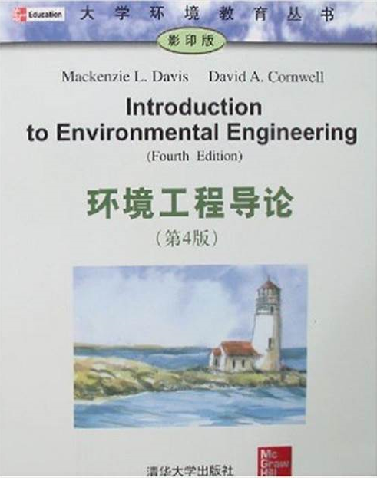

Mackenzie L. Davis and David A. Cornwell, Introduction to Environmental Engineering (Fourth Edition), 2007.

Made by：Sheng-Peng Sun

2016.10.1